ENVIRONMENTAL MONITORING USING IOT

SUBMITTED BY

NAME: S. Navin Raj Kumar

NM ID: au411521106037

PROJECT: ENVIRONMENTAL MONITORING

PHASE – 4 SUBMISSION DOCUMENT

* 

INTRODUCTION

* Environmental monitoring is a tool to assess environmental conditions and trends, support policy development and its implementation, and develop information for reporting to national policymakers, international forums and the public.
* Environmental monitoring is used in the preparation of [environmental impact assessments](https://en.wikipedia.org/wiki/Environmental_impact_assessment), as well as in many circumstances in which human activities carry a risk of harmful effects on the [natural environment](https://en.wikipedia.org/wiki/Natural_environment).
* All monitoring strategies and programs have reasons and justifications which are often designed to establish the current status of an environment or to establish trends in environmental parameters.
* Environmental monitoring products and environmental monitoring software, such as Environmental Data Management Systems (EDMS), facilitate the implementation and monitoring of environmental monitoring and assessment programs, which includes a central data management hub, automated environmental monitoring alerts, compliance checking, validation, quality control, and generation of reports on dataset comparisons.
* As human population, industrial activities, and energy consumption continues to grow, the continued development of advanced, automated monitoring applications and devices is crucial for enhancing the accuracy of environment.
* Environmental monitoring solutions have evolved over the years into Smart Environmental Monitoring (SEM) systems that now incorporate modern sensors, Machine Learning IOT devices.

IMPORTANCE OF ENVIRONMENTAL MONITORING

* The main objective of environmental monitoring is to manage and minimize the impact an organization's activities have on an environment, either to ensure compliance with laws and regulations.

BLOCK DIAGRAM OF ENVIRONMENTAL MONITORING

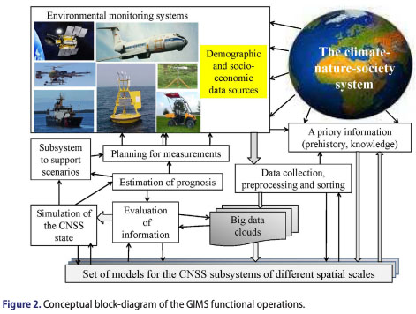

WAYS TO REDUCE THE ENVIRONMENTAL IMPACT

* Stop using plastic bags
* Skip the disposal items
* Go paperless
* Know what to recycle
* Reduce electronic usage
* Drive less
* Adopt water saving objects
* Leave only footprints behind

BENEFITS OF ENVIRONMENTAL MONITORING

* The purpose of an Environmental Monitoring Program is to identify problem areas where potentially harmful microorganisms may be harboring, becoming a source of contamination; as well as verifying the effectiveness of sanitation programs.

TYPES OF ENVIRONMENTAL MONITORING

AIR QUALITY MONITORING

* [Air pollutants](https://en.wikipedia.org/wiki/Air_pollution) are atmospheric substances—both naturally occurring and [anthropogenic](https://en.wikipedia.org/wiki/Human_impact_on_the_environment)—which may potentially have a negative impact on the environment and [organism](https://en.wikipedia.org/wiki/Organism) health.
* Air quality monitoring is challenging to enact as it requires the effective integration of multiple environmental data sources, which often originate from different environmental networks and institutions.
* These challenges require specialized observation equipment and tools to establish air pollutant concentrations, including sensor networks, [geographic information system](https://en.wikipedia.org/wiki/Geographic_information_system) (GIS) models, and the Sensor Observation Service (SOS), a web service for querying real-time sensor data.
* Additionally, consideration of [anemometer](https://en.wikipedia.org/wiki/Anemometer) data in the area between sources and the monitor often provides insights on the source of the air contaminants recorded by an air pollution monitor.

SOIL MONITORING

* Soil monitoring involves the collection and/or analysis of [soil](https://en.wikipedia.org/wiki/Soil) and its associated [quality](https://en.wikipedia.org/wiki/Soil_quality), [constituents](https://en.wikipedia.org/wiki/Soil#Composition), and physical status to determine or guarantee its fitness for use. Soil faces many threats, including [compaction](https://en.wikipedia.org/wiki/Soil_compaction_(agriculture)), [contamination](https://en.wikipedia.org/wiki/Soil_contamination), [organic material](https://en.wikipedia.org/wiki/Soil_organic_matter) loss, [biodiversity](https://en.wikipedia.org/wiki/Soil_biodiversity) [loss](https://en.wikipedia.org/wiki/Biodiversity_loss), [slope stability](https://en.wikipedia.org/wiki/Slope_stability) issues, [erosion](https://en.wikipedia.org/wiki/Soil_erosion), [salinization](https://en.wikipedia.org/wiki/Soil_salinity), and [acidification](https://en.wikipedia.org/wiki/Soil_acidification). Soil monitoring helps characterize these threats and other potential risks to the soil, surrounding environments, animal health, and human health.
* Soil monitoring has historically focused on more classical conditions and contaminants, including toxic elements (e.g., [mercury](https://en.wikipedia.org/wiki/Mercury_(element)), [lead](https://en.wikipedia.org/wiki/Lead), and [arsenic](https://en.wikipedia.org/wiki/Arsenic)) and [persistent organic pollutants](https://en.wikipedia.org/wiki/Persistent_organic_pollutant)
* However, as analytical techniques evolve and new knowledge about ecological processes and contaminant effects disseminate, the focus of monitoring will likely broaden over time and the quality of monitoring will continue to improve.

WATER QUALITY MONITORING

* [Water quality](https://en.wikipedia.org/wiki/Water_quality) monitoring is of little use without a clear and unambiguous definition of the reasons for the monitoring and the objectives that it will satisfy. Almost all monitoring (except perhaps [remote sensing](https://en.wikipedia.org/wiki/Remote_sensing)) is in some part invasive of the environment under study and extensive and poorly planned monitoring carries a risk of damage to the environment
* Some monitoring techniques, such as [gill netting](https://en.wikipedia.org/wiki/Gillnet) [fish](https://en.wikipedia.org/wiki/Fish) to estimate populations, can be very damaging, at least to the local population and can also degrade public trust in scientists carrying out the monitoring.
* Unless individual monitoring projects fit into a wider strategic framework, the results are unlikely to be published and the environmental understanding produced by the monitoring will be lost.

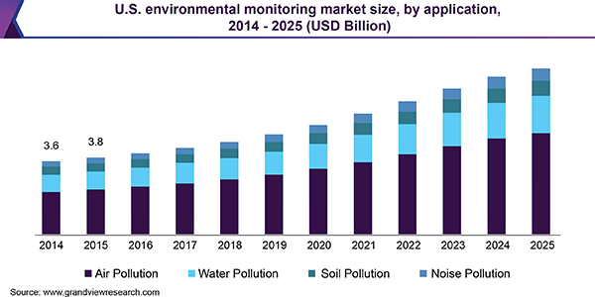

IOT FOR ENVIRONMENTAL MONITORING

FOUR ESSENTIAL COMPONENTS:

* **Monitor the Environment**: Environmental condition monitors across fields, industrial sites and water management systems require installed sensors as well as an information delivery system, such as [Digi XBEE wireless communication modules](https://www.digi.com/xbee) and [sensor connectivity gateways](https://www.digi.com/products/networking/infrastructure-management/sensor-connectivity). These connected devices gather and deliver critical information exactly where is needed.
* **Measure Data**: To measure environmental impact, these systems must make it possible to evaluate key data points that can indicate everything from water and chemical leaks to critical equipment failures. This data can be used by industrial operators and municipalities to [measure their environmental footprint](https://www.nbs.net/articles/two-tools-to-assess-environmental-impacts-of-products) and take action to reduce waste, increase sustainability, manage valuable resources like water, and prevent environmental disasters.
* **Catalog Data**: The massive amounts of data collected from environmental monitoring stations around the globe cannot be overstated. There are global databases that catalog an enormous range of environmental data, such as the [Microsoft Planetary Computer](https://planetarycomputer.microsoft.com/catalog). Industrial sites and other enterprises, similarly, must utilize cloud and data center storage to catalog the gathered data for accessibility by business applications.
* **Provide Actionable Insights from the Data and Analysis**: The critical end game is actionable insights from data. [Digi’s IoT solutions](https://www.digi.com/products), integrated with cloud applications like Microsoft Azure and Amazon Web Services, deliver data into complex software systems that enable personnel to gain those insights, get alerts and notifications, and take action.

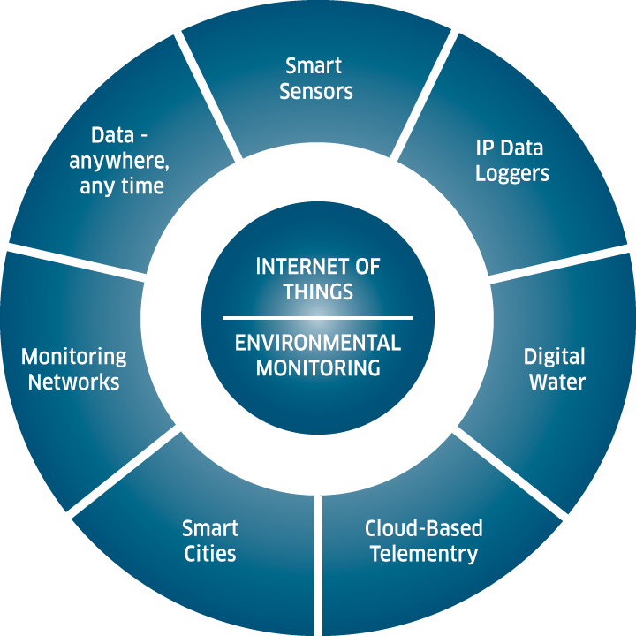

CONSIDERATIONS OF ENVIRONMENTAL MONITORING

* Environmental considerations include strategies, development guidelines and land use plans related to greenspaces, derelict and contaminated land, nature conservation and biodiversity, flooding, air and water quality, green design and climate change.
* Investigations and evaluation of trends as well as excursions from alert and action limits.
* Corrective actions to be implemented in response to environmental excursions.

BENEFITS OF USING IOT BASED ENVIRONMENTAL MONITORING

* **Improved understanding of the environment via data**: With real-time data feeds being supplied by remotely deployed IoT sensors, businesses and organization can better understand and quantify the environment. From here, targeted actions can be taken to reduce environmental impact or to spot problems, such as excessive CO2, noise or airborne chemicals as they occur.
* **Improved efficiency**: With real-time data, organizations can identify and address any problems long before they become more serious. By employing warning alarms, businesses can be more reactive and proactive. This can result in a better working environment, cost savings and less downtime.
* **Increased sustainability:** IoT environmental monitoring systems help organizations identify areas where they can reduce their areas of environmental stress for employees and stakeholders, thus helping them be more sustainable in the long term.
* **Business Growth**: Companies often need to comply with environmental standards in order to assure their customers that they are a progressive organization whose values chime and adhere to their own policies and direction of travel. Producing evidence-based systems and results can provide greater surety that measures and controls are in place, fitting both the contexts of the business and its (or its customers) environmental concerns.

FOUR BASIC STEPS FOR ENVIRONMENTAL MONITORING

* **Observation -** The first step in the environmental monitoring process is to observe and collect data. This involves using sensors or other IoT devices to measure factors such as air quality, temperature, and humidity levels.These connected IoT devices gather data about the environment and transmit it to a central hub. From here, the data can be reviewed in real-time or used for further analysis off line.
* **Analysis** - The next step is to analyze the data collected by IoT devices. This includes looking at trends over time, identifying areas of concern, and any correlations between environmental variables, time of day, behavior and the relationships between indoor and outdoor metrics. sensing devices pick out key points of the data that indicate everything from chemical and water leaks to air pollution levels. This data analysis can help businesses measure their environmental fact and make informed decisions about how to reduce their environmental impact.

* **Storage** - Once the data has been analyzed, it needs to be stored so that it can be accessed in the future. IoT environmental monitoring systems make this easy by storing the data in a secure cloud-based database, allowing businesses to access the data whenever they need it and analyse how their environmental impact is changing over time. Global databases, such as the[Microsoft Planetary Computer](https://planetarycomputer.microsoft.com/catalog), catalogue enormous quantities of environmental data from around the world – although not every cloud database is that large.
* **Action** - Finally, businesses need to be able to take action based on the data that has been gathered and analysed. IoT-enabled environmental monitoring systems can provide insights into how businesses can best reduce their environmental impact, such as by using renewable energy sources or introducing water conservation measures. These actionable insights may involve changing operational processes, implementing new technologies, or even making changes to their overall business strategy.

SCOPE OF ENVIRONMENTAL MONITORING

* *Environmental Monitoring and Assessment* emphasizes technical developments and data arising from environmental monitoring and assessment, the use of scientific principles in the design of monitoring systems at the local, regional and global scales, and the use of monitoring data in assessing the consequences of natural resource management actions and pollution risks to man and the environment.

ADVANTAGES OF ENVIRONMENTAL MONITORING

* The primary benefit of environmental monitoring is to check that your policy statement, plan, or condition on a resource consent has resulted in the environmental outcome you expected. It provides information to understand the current state of the environment and assess whether things are getting better or worse.

IOT ENVIRONMENTAL APPLICATIONS

* Extreme weather monitoring
* Vehicle tracking
* Waste management
* Water safety
* Environmental monitoring
* Endangered species protection
* Commercial forming

CONCLUSION

* The Comprehensive Everglades Restoration Plan (Restoration Plan) Monitoring and Assessment Plan (MAP) is grounded in current scientific theory and practice of adaptive management. The least developed aspects of the planned adaptive management are feedback mechanisms to connect monitoring to planning and management.
* Restoration goals, objectives, and targets for the Everglades are inadequately defined and are not reconciled with the large-scale forces of change in south Florida.